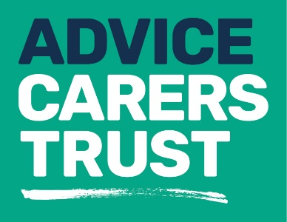

Your rights
_____________________________________________
Fact sheet 17: When caring ends
Dealing with personal affairs
When someone dies, everything they own - their money, property and possessions - is called their estate. If the person that died has left a will, this will indicate how they wanted their estate to be divided after their death.
The estate cannot be used to pay bills or debts, or be divided up for gifts and inheritance until either:
- the will has been granted probate – this is a formality which confirms that a will is legally in order
- a grant of administration has been given – this is a formality which allows the personal representative to deal with the estate when there is no will.
This means that any bank accounts in the deceased person’s name will be frozen until the formalities have been completed. Bank accounts in joint names can be used by the other account holder.
Power of Attorney
If you had Power of Attorney for the person you cared for, this will cease as soon as the person dies. You will not be able to continue to use their bank account, or carry out any business on their behalf.
Inheritance Tax
You may have to pay inheritance tax, depending on the amount of money in the estate. However, Inheritance Tax does not have to be paid if the estate goes to the deceased’s spouse or civil partner, no matter how much they inherit.

Tell Us Once service
A registrar will explain the Tell Us Once service when you register the death. They will either:
- complete the Tell Us Once service with you
- give you a unique reference number so you can use the service yourself online or by phone. You must use the service within 84 days of getting your unique reference number.

What you will need when you register a death:
- date of birth
- National Insurance number
- driving licence number
- vehicle registration number
- passport number
- details of any benefits and entitlements the deceased may have been receiving (e.g state pension, income support, housing benefit, library card etc)
- Blue Badge (if applicable)
- name, address and contact details of the person or company dealing with their estate (property, belongings and money), known as their ‘executor’ or ‘administrator’
- details of any public sector or armed forces pension schemes they were getting or paying in to.
Telephone: 0800 085 7308
Online: gov.uk - Tell Us Once
The Good Grief Trust
The Good Grief Trust is a charity that exists to help all those suffering grief in the UK. They acknowledge peoples grief and provide reassurance, a virtual hand of friendship and ongoing support.
Their vision is to bring all bereavement services together around the country, to ensure that everyone receives the support they need to move forward with their lives.
Email: hello@thegoodgrieftrust.org
Website: www.thegoodgrieftrust.org
For more information about our services please contact us on:
Telephone: 01895 811206
Email: office@carerstrusthillingdon.org
Website: www.carerstrusthillingdon.org

